**Assignment-Courier Management System**

**Database Schema and Codes**

**Entities**

• **User**: Manages the users sending couriers.

* Attributes: UserID (PK), Name, Email, Password, ContactNumber, Address

• **Courier**: Tracks courier details.

* Attributes: CourierID (PK), SenderName, SenderAddress, ReceiverName, ReceiverAddress, Weight, Status, TrackingNumber, DeliveryDate, UserID (FK)

• **CourierServices**: Manages the types of delivery services.

* Attributes: ServiceID (PK), ServiceName, Cost

• **Employee**: Records employee details.

* Attributes: EmployeeID (PK), Name, Email, ContactNumber, Role, Salary

• **Location**: Stores location information.

* Attributes: LocationID (PK), LocationName, Address

• **Payment**: Records payments made for couriers.

* Attributes: PaymentID (PK), CourierID (FK), LocationID (FK), Amount, PaymentDate

**Relationships**

* **User ↔ Courier (1-to-Many)**: One user can send multiple couriers; each courier belongs to one user.
* **Courier ↔ Payment (1-to-1)**: Each courier has one payment, and each payment is for one courier.
* **Location ↔ Payment (1-to-Many)**: One location handles multiple payments, but each payment is linked to one location.
* **CourierServices ↔ Courier (Many-to-Many)**: A courier can use multiple services, and services can apply to multiple couriers (requires a junction table, not yet defined).



This command creates a new database named CourierManagementSystem within the database management system.

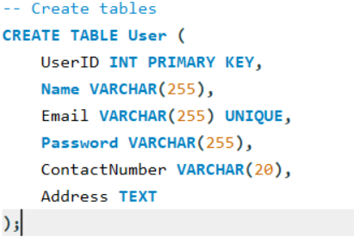

Creates a User table with columns for user details including an integer primary key UserID, and fields for name, email (unique), password, contact number, and address.

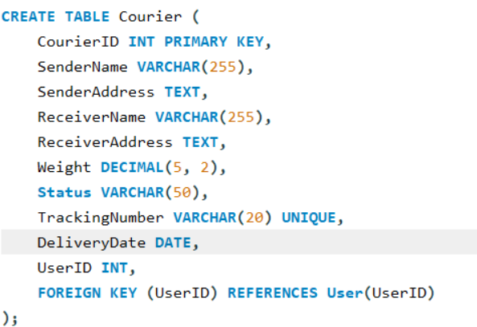

Creates a Courier table with columns for courier details, including an integer primary key CourierID, sender and receiver names and addresses, weight, status, unique tracking number, delivery date, and a foreign key referencing the User table.

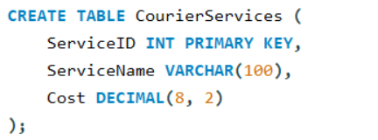

Creates a CourierServices table with columns for service details, including an integer primary key ServiceID, service name, and cost.

Creates an Employee table with columns for employee details, including an integer primary key EmployeeID, name, unique email, contact number, role, and salary.

Creates a Location table with columns for location details, including an integer primary key LocationID, location name, and address.

Creates a Payment table with columns for payment details, including an integer primary key PaymentID, foreign keys for CourierID and LocationID, payment amount, and payment date.

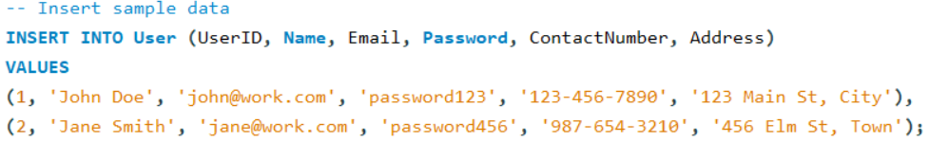

Inserts two sample user records into the User table with specified values for UserID, name, email, password, contact number, and address.



Inserts two sample courier records into the Courier table with specified values for CourierID, sender and receiver names and addresses, weight, status, tracking number, delivery date, and UserID.

Inserts two sample courier service records into the CourierServices table with specified values for ServiceID, service name, and cost.

Inserts two sample employee records into the Employee table with specified values for EmployeeID, name, email, contact number, role, and salary.

Inserts two sample location records into the Location table with specified values for LocationID, location name, and address.

Inserts two sample payment records into the Payment table with specified values for PaymentID, CourierID, LocationID, amount, and payment date.

Lists all records from the User table.

Retrieves all courier records for the user with UserID 1

Lists all records from the Courier table.



Retrieves all details of the courier with CourierID 1.

Lists all deliveries associated with the courier having CourierID 1.

Retrieves all packages that have not been delivered.



Lists all packages scheduled for delivery today.



Retrieves all packages that are currently marked as 'In Transit'.



Calculates the total number of packages for each courier grouped by UserID.

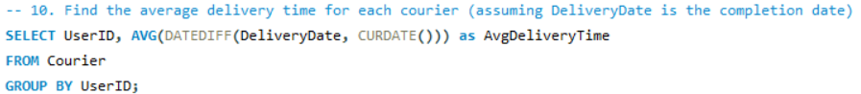

Finds the average delivery time for each courier based on the difference between the delivery date and the current date.



Lists all packages from the Courier table with a weight between 1.0 and 3.0.

Retrieves all employee records whose names contain 'John'.

Retrieves courier records with associated payments greater than $50 by joining the Courier and Payment tables.